Exposed Terminal Problem

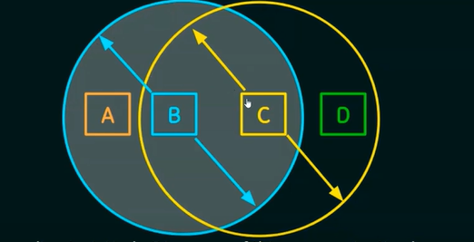

1. Suppose B is sending to A. Node C is aware of this communication because it hears B’s transmissions.
   1. It would be a mistake for C to conclude that it cannot transmit to anyone just because it can hear B’s transmission
   2. Suppose C wants to transmit to node D.
   3. This is not a problem since C’s transmission to D will not interfere with A’s ability to receive from B.

Solution:

Multiple Access Collision Avoidance (MACA) Algorithm – RTS and CTS